HCCASA CALENDAR + ANNOUNCE LIST January 2021

--------------------------------------------------------------------------------------------------------------------------------------------------------------------------------------------------------------------------------------------------------------------------------------
Press CRTL+Click of the links below to go straight to the topic:

COVID-19
Court Hearings + Protocols
End of December + January (so far) Court / Meeting Calendar
Meetings
Child Visits
CASA Office Hours + Holiday Schedule
CASA LIVE Virtual Training
CASA At-Your-Own Pace Training
Visitation Protocols
Virtual Visit Tools for CASAs
--------------------------------------------------------------------------------------------------------------------------------------------------------------------------------------------------------------------------------------------------------------------------------------

--------------------------------------------------------------------------------------------------------------------------------------------------------------------------------------------------------------------------------------------------------------------------------------

COVID-19:
COVID-19 positive cases continue to rise in the Hill Country. We’re maintaining our COVID-19 webpage with current information about CASA work.

Please consider that COVID-19 moves more quickly than word can travel. We will continue to let you know if we learn your CASA child’s placement has been exposed / has a positive case; however this information is rarely given to us immediately.

Be cautious in your travels and face to face contacts.

Texas CASA has suspended the requirement for face to face contact through the end of January 2021. While local case numbers are climbing, we urge you to consider having twice monthly virtual contact with children/placements, to replace your face to face visits. We will share Texas CASA’s next directive in the February announcements.

--------------------------------------------------------------------------------------------------------------------------------------------------------------------------------------------------------------------------------------------------------------------------------------

--------------------------------------------------------------------------------------------------------------------------------------------------------------------------------------------------------------------------------------------------------------------------------------

COURT HEARINGS: All will be Virtual until Further Notice
HCCASA Court Swear In: “Name, Hill Country CASA, Guardian Ad Litem for the Child(ren)”.
Each week, your supervisor will contact you as soon as we have call in information for your hearing (generally Friday the week before, or Monday the week of court).
You may choose to attend court via phone or via Zoom video. Let us know if you want to have a Zoom practice session before your hearing!

PROTOCOLS FOR HCCASA STAFF/VOLUNTEERS ATTENDING HEARINGS BY PHONE
- Use your phone and dial 1 (346) 248 – 7799 about 3-5 minutes before the hearing (expect a brief hold)

- Enter the Meeting ID and Passcode listed above, to the left of your name

- Use the MUTE button on your phone at all times when not speaking

- Listen for your Case Supervisor to announce themselves, and then unmute and announce yourself - “Name, Hill Country CASA, Guardian Ad Litem for the Child(ren)”

- When called upon by the Judge, unmute yourself to give oral testimony, and then mute yourself again

- Hang up when your hearing is concluded

PROTOCOLS FOR HCCASA STAFF/VOLUNTEERS ATTENDING HEARINGS BY VIDEO
- Log into your account at zoom.us and choose “Join Meeting”

- Enter the Meeting ID and Passcode listed above, to the left of your name

- Use the MUTE button on the bottom left of the screen at all times when not speaking (when the MUTE is ON, there will be a red line through the microphone icon)

- Listen for your Case Supervisor to announce themselves, and then unmute and announce yourself - “Name, Hill Country CASA, Guardian Ad Litem for the Child(ren)”

- When called upon by the Judge, unmute yourself to give oral testimony, and then mute yourself again

- Click End button on bottom right of screen when your hearing is concluded

-------------------------------------------------------------------------------------------------------------------------------------------------------------------------------------------------------------------------------------------------------------------------------------

-------------------------------------------------------------------------------------------------------------------------------------------------------------------------------------------------------------------------------------------------------------------------------------

CASA CALENDAR JANUARY 2021
Abbreviations: Adversarial Hearing (Removal), Family Group Conference (FGC), Transition Plan Meeting (TPM), 60 Day/Status Review (Status), Initial Permanency Hearing (IPH), Permanency Review before Final Order (PH), Permanency Review after Final Order (PR), Progress Review (Progress), Permanency Planning Meeting (PPM), Pre-Trial Conference (PTC), Merits Trial (Merits), Adoption (Adopt) and Dismissal (Final).
All Hearings / Meetings will be held by Zoom / Phone Call. We will send an updated calendar each week to those who need it with call-in information and protocols.
Monday, December 21, Mediation
1:00 Moreland Andrews (994) CR

Wednesday, December 30, Kendall Court
9:00 Grandazzo (Merits) Taylor (067) RL
9:30 Lochte (PR) Darling (862) RL
10:00 Villalobos (PR) Oates (568) RL

Wednesday, December 30, Bandera Court
10:30 Yeager (PH) Putnam (243) GR
11:30 Holsey (IPH) Hug (537) GR
1:00 Bowen (PR) Keyes (578) GR
1:30 Sheeds (PR) Weaver (922) GR

Wednesday, January 6, Kerr Court
9:00 Stewart-Stokes (IPH) Luttrell (676) AH
9:30 Schneider (Merits) Griffith (428) CR
10:00 Salinas (IPH) Clyburn (597) RL
10:30 Ybarra (IPH) Martin (660) AH
11:00 Guzman (PR) Taylor (067) RL
11:30 Burrow (Status) Unassigned AH

Tuesday, January 12, Mediation
10:30 Mayes Prince (105) RL
Wednesday, January 20, Kerr Court
9:30 Meredith (PR) Williams (628) RL

Friday, January 22, Bandera Court
9:00 Hicks (PR) Hug (537) GR
9:30 Grover (PH) Fields-Himes (496) GR
10:00 Downs (Merits) Bardwell (458) GR
10:30 Morrison (PH) Fields-Himes (496) GR
11:00 Beadman (PR) Peterson (551) GR
11:30 Martinez-Parks (PH) Taylor (902) GR
1:00 Servellon (Status) Brooks (242) GR
1:30 Jennings (Merits) Mirsky (489) GR

Friday, January 22, Gillespie Court
2:00 Nieto (Status) Wienecke (331) AH

Tuesday, January 26, Kerr Court *Judge Ables
9:00 Brown Schoenfeld (636) AH

Wednesday, January 27, Kendall Court
9:30 Seitzer (Merits) Darling (862) RL
10:00 Williams, J. (Status) Unassigned RL

Thursday, January 28, Gillespie Court
9:00 Tubbs-Servantez (Status) Curry (327) AH
9:30 De La Cruz (PR) Hendersons (976) AH

Thursday, January 28, Bandera Court
10:00 Perales (Merits) Helm (304) GR

-------------------------------------------------------------------------------------------------------------------------------------------------------------------------------------------------------------------------------------------------------------------------------------

--------------------------------------------------------------------------------------------------------------------------------------------------------------------------------------------------------------------------------------------------------------------------------------

MEETINGS: Will be held Virtually until Further Notice
As meetings are scheduled on your case, your Supervisor will contact you directly with call-in information.
Your supervisor will give you the option to attend meetings and mediations either virtually (with video) or by phone only.
If you choose to attend meetings virtually, please be mindful of your background and follow the normal protocols for meetings in person regarding dress, decorum.
--------------------------------------------------------------------------------------------------------------------------------------------------------------------------------------------------------------------------------------------------------------------------------------

--------------------------------------------------------------------------------------------------------------------------------------------------------------------------------------------------------------------------------------------------------------------------------------

CHILD VISITS:
Thank you all, for your diligence in maintaining contact in the best interest of our children through the pandemic. Whether by virtual, phone or careful in-person visits, you all have done an excellent job of keeping in touch and providing support to the children, families, placements and Judges – thank you!

Texas CASA’s Board of Directors has waived the requirement for face to face contact with your assigned children through January 2021.

In times where COVID cases are rising locally (and/or in the child’s placement community) we recommend you make virtual contact twice monthly with the children and their placements – to replace the face to face contact you’d normally have.

In times of lower COVID cases, we’ll encourage you to make face to face visit with your children (as we did in June and September … and hopefully soon in 2021).
Per court order, all adult participants in face to face visits must wear a mask for the duration of the visit. Please adhere to the HCCASA visitation protocols if you will be making a face to face visit.

HCCASA has masks, disposable gloves and hand sanitizer for you – let us know if you would like to drop by for contactless pickup and we will make an appointment at a time convenient for you.

------------------------------------------------------------------------------------------------------------------------------------------------------------------------------------------------------------------------------------------------------------------------------------

--------------------------------------------------------------------------------------------------------------------------------------------------------------------------------------------------------------------------------------------------------------------------------------

CASA OFFICE:
Until HCCASA staff have received the COVID-19 vaccine, we anticipate to maintain a modified in-office schedule in the best interest of our children, volunteer and organizational needs and to be good stewards of public health.

When the office is open, we welcome visitors by appointment (and subject to screening and temperature check upon arrival). All visitors and staff will be required to wear a mask the entire duration of their visit to the CASA office.

If you need a face to face appointment on a day the office is not open, contact your Supervisor and we’ll be pleased to meet your need.

You’ll notice when you visit the front door is locked; this is to minimize walk-in traffic. Please ring the doorbell for service.

Though our in-office hours are reduced for the time being, we will still be working normal hours (mostly remotely) and will continue to be here for support to all our volunteers doing important work with children.

The CASA staff will go on Christmas Holiday at noon on December 18, 2020, the CASA office will remain closed through the end of the year.

Staff will work remotely on December 28 – noon on December 30, 2020; and then go on New Years holiday through December 31, 2020.

The staff will return to work at at 9 AM on January 4, 2021, and the CASA office will open under modified in-office schedule until further announcement:

Stephanie / Amy – in office Mondays from 9 AM – 1 PM

Goldie / Raquel – in office Tuesdays from 9 AM – 1 PM

Colleen / Judy – in office Thursdays from 9 AM – 1 PM

--------------------------------------------------------------------------------------------------------------------------------------------------------------------------------------------------------------------------------------------------------------------------------------

--------------------------------------------------------------------------------------------------------------------------------------------------------------------------------------------------------------------------------------------------------------------------------------

CASA VIRTUAL TRAINING:
Don’t forget to register for the 2021 Ad Litem Seminar! More information is on our seminar page at www.hccasa.org/seminar.
If you want to attend this event live, email Amy@hccasa.org to get your registration details. All HCCASAs will have access to the Seminar videos following the live event.

CASA Zoom Calls – here’s the schedule for January – March 2021. Amy will continue to send out a reminder email the Monday before each Zoom; we hope you’ll join us as you can! All Zooms will be Tuesdays at 11:30 AM.

January 12 – Kinship placements + services available
January 19 – Self-care during the pandemic (special presentation from MHDD Hays County)
February 2 – TARE (Texas Adoption Resource Exchange); regarding children available for adoption
February 16 – Medical Advocacy for CASA kids
March 2 – PMC 101: Introduction to Service of PMC Children
March 9 – PMC 201: Primary and Concurrent Permanency Planning
March 30 – PMC 301: Preparing Youth for Adult Living

--------------------------------------------------------------------------------------------------------------------------------------------------------------------------------------------------------------------------------------------------------------------------------------

--------------------------------------------------------------------------------------------------------------------------------------------------------------------------------------------------------------------------------------------------------------------------------------

AT YOUR OWN PACE LEARNING:
Resources/Independent Study Pages on hccasa.org: We have posted tons of local resources and online trainings on our webpages devoted to these two subjects – much of which is based on your feedback in our Spring 2020 HCCASA Program Evaluation.
Click the links below to go straight to these pages.
HCCASA Resources & Independent Study (and Vimeo Account Info)

--------------------------------------------------------------------------------------------------------------------------------------------------------------------------------------------------------------------------------------------------------------------------------------

CHILD VISIT PROTOCOLS - The following conditions will apply to visits for the foreseeable future:
- Both you as the CASA advocate and the current placement need to agree to the visit. If the placement has an objection, find alternative means to make the visit. Those alternatives could be:
- Drive by visit where the placement and child go out to the porch and/or sidewalk to visit with you in your car
- Visit outside with social distancing and masks
- Meet placement/children at a public location and visit over a meal
- If no other options, do a virtual visit – let your supervisor know if placement will not allow you to visit
- Before your visit, check with the placement about any contact with someone who has been sick, quarantined or tested positive for COVID-19 (see screening questions on the next page). You should also be ready to answer these questions about yourself.
- During visits you are encouraged to wear a mask and practice social distancing to the best of your ability. If a placement requires that you wear a mask, please do so (CASA office can provide a mask for you and the child(ren) you visit). In addition, different counties and municipalities have different emergency rules, so please be aware whenever you travel to those areas. These precautions are to protect you from bringing illness home or from bringing illness to a child’s home.
- Until further notice, transportation of children is suspended. If you need an exception, contact the Program Director.
- Due to the ability of this virus to live on surfaces, please do not bring your children gifts, clothing or toys. If your child has an immediate need, please contact your Case Supervisor and arrangements will be made to have a gift card provided to the placement to meet that need.
  - You may take a meal or snack to the visit with you to share with your child; please don’t take any food not intended to be consumed during the visit.
- Courts, Mediations and CPS meetings are still operating via teleconference/Zoom until August 1, 2020. We will continue to provide you a schedule with access information in advance, as we have over the last months.
- Please make sure to documents all of your contacts and visits (whether virtually, by phone or in person) in Optima and in a timely manner. Our grants are dependent on the documentation you keep.
- Should you become ill and suspect you have exposed a child after a visit, please make sure to notify the individuals with whom you have been in contact so they can take the appropriate steps. Also, notify your Case Supervisor.
- If you identify issues of abuse or neglect during a visit, please report the information you obtained to:
- CASA Case Supervisor
- CPS Caseworker through email and phone call
- CPS Child Abuse Hotline 1-800-252-5400
- Contact local law enforcement and request a welfare check

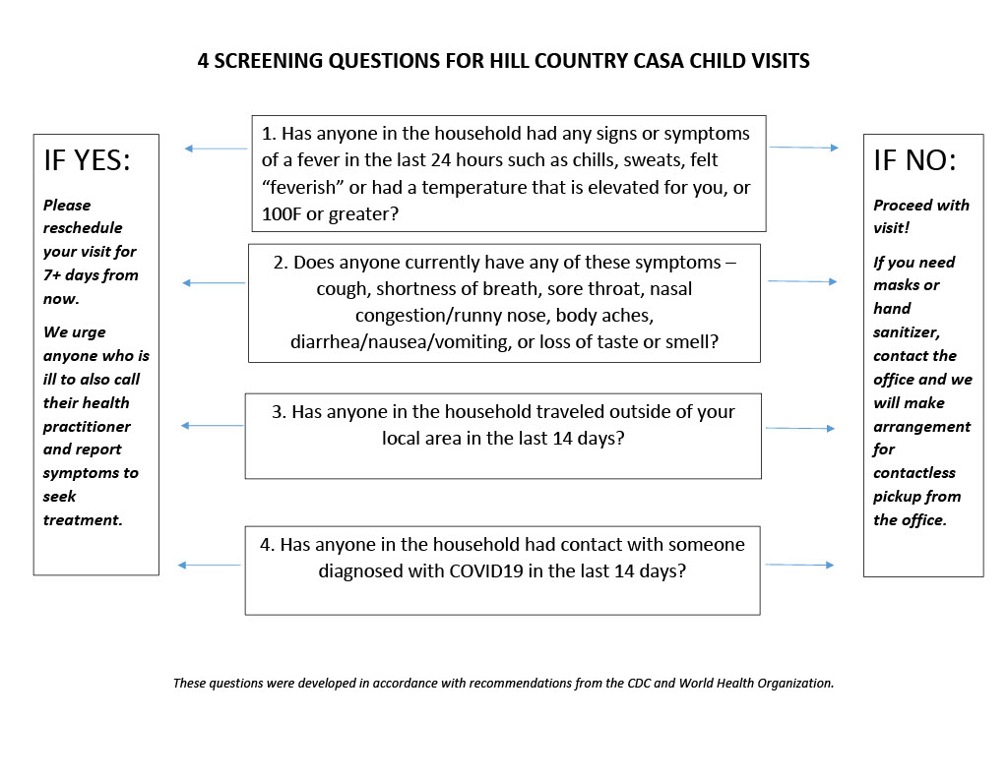

Virtual Visit Tools
Here are three tools for virtual (video) visits with children, placements and others involved in our cases. Depending on your device and the device you’re connecting to, you may use one or more of these options.

App Name | Who can Use? | YouTube Instructions
FaceTime | Apple Device to Apple Device | https://www.youtube.com/watch?v=NyfaJR7BilQ
Google Duo | Android Device to Any Device | https://www.youtube.com/watch?v=c-EMHbvsV7Y
Zoom.us | Any Device to Any Device | https://www.youtube.com/watch?v=HbYHaNvCw9M

