HCCASA CALENDAR + ANNOUNCE LIST NOVEMBER 2020

--------------------------------------------------------------------------------------------------------------------------------------------------------------------------------------------------------------------------------------------------------------------------------------
Press CRTL+Click of the links below to go straight to the topic:

COVID-19 News and Updates
NEW ZOOM INFO FOR CASAs for Court Hearings
November Court / Meeting Calendar
Meetings
Child Visits
CASA Office
CASA LIVE Virtual Training
CASA At-Your-Own Pace Training – Distinguished Speaker Series from Texas CASA starts October 29
Visitation Protocols
Virtual Visit Tools for CASAs
--------------------------------------------------------------------------------------------------------------------------------------------------------------------------------------------------------------------------------------------------------------------------------------

--------------------------------------------------------------------------------------------------------------------------------------------------------------------------------------------------------------------------------------------------------------------------------------

COVID-19:
We continue to monitor COVID-19 situation in all of our local counties, and statewide.
We are also monitoring the situation within our own child welfare community and gathering information as we receive it from you all, placements, other CASA programs, and CPS.
There are many factors affecting the ability to receive timely information about exposure or positive cases in our foster care facilities and homes. Please be vigilant in adhering to health authority guidelines and HCCASA Visitation Protocols to keep yourself safe.
--------------------------------------------------------------------------------------------------------------------------------------------------------------------------------------------------------------------------------------------------------------------------------------

--------------------------------------------------------------------------------------------------------------------------------------------------------------------------------------------------------------------------------------------------------------------------------------

COURT HEARINGS:
All hearings will happen virtually until further notice and definitely through the 2020 holidays.
HCCASA Court Swear In: “Name, Hill Country CASA, Guardian Ad Litem for the Child(ren)”.
Each week, your supervisor will contact you as soon as we have call in information for your hearing.
Now that we know court will be happening by Zoom for the foreseeable future, we are going to host a training on how to attend court by Zoom (using video, not just phone as we have in the past).
Any CASA that would like to attend Court by Zoom should first attend the training; the live session will be held at 11:30 on November 3; or if you can’t make the live session, watch the video on our vimeo account after the 3rd.
You are welcomed to continue to attend court by phone only, if that is your preference.

-------------------------------------------------------------------------------------------------------------------------------------------------------------------------------------------------------------------------------------------------------------------------------------

-------------------------------------------------------------------------------------------------------------------------------------------------------------------------------------------------------------------------------------------------------------------------------------

CASA CALENDAR NOVEMBER 2020
Abbreviations: Adversarial Hearing (Removal), Family Group Conference (FGC), Transition Plan Meeting (TPM), 60 Day/Status Review (Status), Initial Permanency Hearing (IPH), Permanency Review before Final Order (PH), Permanency Review after Final Order (PR), Progress Review (Progress), Permanency Planning Meeting (PPM), Pre-Trial Conference (PTC), Merits Trial (Merits), Adoption (Adopt) and Dismissal (Final).
All Hearings / Meetings will be held by Zoom / Phone Call. We will send an updated calendar each week to those who need it with call-in information and protocols.

Monday, November 2, Gillespie Court
9:30 Brandt-Ahrendt (Adversary) Taylor (067) AH

Monday, November 2, Kerr Court *Judge Patillo
10:30 Demaray (PR) Andersons (919) RL

Monday, November 2, Kerr Family Meetings
1:30 Wheeler (Mom) Enochs (567) AH
3:30 Wheeler (Dad) Enochs (567) AH

The CASA Office will close @ 1 PM on Election Day, November 3; the office will reopen at 9 AM on November 4.

Wednesday, November 4, Kerr Court
9:00 Pope (PH) Bluff (977) AH
9:30 Runyan (Merits) Gramatikakis (136) RL
10:00 Lacey (Status) Buck (389) RL
11:00 Roach-Morris (Merits) Blackburn (519) CR
1:00 Stewart (Motion) Luttrell (676) AH
1:30 Myhre-Beggs (Removal) Berlin (823) RL

Wednesday, November 4, Kerr Court *Visiting Judge
1:00 Aleman, K. (PR) Hecht (744) RL
1:30 Moreland (Permanency/Merits) Andrews (994) CR
2:00 Kuhlmann-Iverson (Merits) CR
2:30 Torres (PH) J. Sheehan (660) SC

The CASA Office will be closed Wednesday, November 11 in observance of Veterans Day; the office will reopen at 9 AM on Thursday, November 12.

Thursday, November 12, Family Meetings
9:30 Seitzer Darling (862) RL
1:00 Bird Daniels (606) GR
2:00 Maxey Andersons (919) GR
3:00 Lind (Dad’s Meeting) McDonald (119) AH

Friday, November 13, Bandera Court
9:00 Hicks (Merits) Hug (537) GR
9:30 Rodney (PH) Bardwell (458) GR
10:00 Downs (PH) Bardwell (458) GR
10:30 Maxey (IPH) Andersons (919) GR
11:00 Bennack-Brawner (Status) Weber (688) GR
11:30 Servellon (Removal) Brooks (242) GR

Friday, November 13, Family Meeting
2:00 Carlos (Mom’s Meeting) Kirchner (529) AH

Monday, November 16, Kerr Court
10:00 Bernal (PR) Early (176) RL
11:00 Crider (Status) Whitecotton (310) RL
11:30 McCraw (Status) Gramatikakis (136) RL

Monday, November 16, Mediation
1:00 Moran-Dulaney Trono (919) CR

Monday, November 16, Family Meetings
1:30 Meredith Williams, K. (628) RL
2:30 Aleman, K. Hecht (744) RL

Tuesday, November 17, Family Meeting
10:30 Roach-Morris Blackburn (519) CR

Wednesday, November 18, Kendall Court
9:00 Seitzer (PH) Darling (862) RL

Wednesday, November 18, Kendall Court *Visiting Judge
9:30 Sotello-Mora (PR) Jewell (115) RL
10:00 Ortega-Munsterteiger (PH) Berlin (823) RL

Thursday, November 19, Gillespie Court
9:30 Adams (IPH) Williams (868) AH
10:00 Lind (Status) McDonald (119) AH

The CASA office will be closed from November 23 – 27.
CASA staff will work remotely November 23 – 24 and will be responsive to your needs.
CASA staff will observe the Thanksgiving holiday November 25 – 27.
The CASA office will reopen at 9 AM on Monday, November 30.

-------------------------------------------------------------------------------------------------------------------------------------------------------------------------------------------------------------------------------------------------------------------------------------

--------------------------------------------------------------------------------------------------------------------------------------------------------------------------------------------------------------------------------------------------------------------------------------

MEETINGS:
As meetings are scheduled on your case, your Supervisor will contact you directly with call-in information.
We expect meetings and mediations to continue to be held virtually for the foreseeable future.
Your supervisor will give you the option to attend meetings and mediations either virtually (with video) or by phone only.
If you choose to attend meetings virtually, please be mindful of your background and follow the normal protocols for meetings in person regarding dress, decorum as outlined in the training scheduled on November 3rd (and available in vimeo after that).
--------------------------------------------------------------------------------------------------------------------------------------------------------------------------------------------------------------------------------------------------------------------------------------

--------------------------------------------------------------------------------------------------------------------------------------------------------------------------------------------------------------------------------------------------------------------------------------

CHILD VISITS:
Texas CASA’s Board of Directors met in late September and decided to continue the Moratorium on the requirement for face to face contact with children through January 2021. Meaning that until at least 1/31/2021, the requirement for face to face contact with your assigned children is waived.
However, based on feedback from you and in the best interest of our children, we are considering volunteer requests for a face to face visit on a case by case basis.
Please let your Case Supervisor know if you feel you need to have a face to face visit with your child(ren). The Case Supervisor and Program Director will discuss the situation and offer a waiver to allow the visit whenever safely possible.
Per court order, all adult participants in face to face visits must wear a mask for the duration of the visit. We will provide you with a copy of the HCCASA visitation protocols if you will be making a face to face visit.
HCCASA has masks, disposable gloves and hand sanitizer for you – let us know if you would like to drop by for contactless pickup anytime between 9 and 5 Monday – Thursday.

------------------------------------------------------------------------------------------------------------------------------------------------------------------------------------------------------------------------------------------------------------------------------------

--------------------------------------------------------------------------------------------------------------------------------------------------------------------------------------------------------------------------------------------------------------------------------------

CASA OFFICE:
CASA office will be open from 9 AM to 5 PM, Monday – Thursday throughout November, with the following exceptions:

November 3 – we will close at 1 PM to allow staff time to vote

November 11 – we will be closed for Veterans Day

November 23 – 27 the CASA office will be closed for Thanksgiving; staff will work remotely on November 23 – 24 and observe the holiday November 25 – 27

We will generally work from home on Fridays to continue to practice our remote work skills. However if you need a face to face appointment or have other needs on Fridays, please let us know so we can make arrangements to be at the office to support you.

We welcome visitors by appointment (and subject to screening and temperature check upon arrival). All visitors and staff will be required to wear a mask the entire duration of their visit to the CASA office.

You’ll notice when you visit the front door is locked; this is to minimize walk-in traffic. Please ring the doorbell for service.

--------------------------------------------------------------------------------------------------------------------------------------------------------------------------------------------------------------------------------------------------------------------------------------

--------------------------------------------------------------------------------------------------------------------------------------------------------------------------------------------------------------------------------------------------------------------------------------

CASA VIRTUAL TRAINING:
Weekly Zooms will be Tuesdays from 11:30 – 1 PM, and will occur every week until Thanksgiving week (then we’ll resume these weekly meetings in January 2021). We hope you will join us for these discussions when you’re able, we look forward to seeing you.

Link to join by video: click here
Meeting ID: 851 4468 0554
Password: 265407

OR join by phone only –

Call #: (346) 248-7799
Meeting ID: 851 4468 0554
Password: 265407

Calendar of Topics for Brown Bags: ALL brown bags will have a waiting room and we will be practicing the court protocols as we begin each brown bag.

November 3 - Attending virtual court by video
November 10 - The Law & Best Interest of Children
November 17 - Parental Presumption
November 24 - Psychotropic Medications

--------------------------------------------------------------------------------------------------------------------------------------------------------------------------------------------------------------------------------------------------------------------------------------

--------------------------------------------------------------------------------------------------------------------------------------------------------------------------------------------------------------------------------------------------------------------------------------

AT YOUR OWN PACE LEARNING:
Resources/Independent Study Pages on hccasa.org: We have posted tons of local resources and online trainings on our webpages devoted to these two subjects – much of which is based on your feedback in our Spring 2020 HCCASA Program Evaluation.
Click the links below to go straight to these pages.
HCCASA Resources & Independent Study (and Vimeo Account Info)

Texas CASA Distinguished Speaker Series: This year, Texas CASA will not be hosting an in-person Texas CASA Conference. They are going to have a series of Zooms instead, with four planned discussions with national experts on various relevant topics, on Thursdays at 11 AM from October 29 – November 18.
We encourage you to Register and tune in to any or all of these talks as you’re available. Don’t forget to log these hours in Optima for continuing education credit!

--------------------------------------------------------------------------------------------------------------------------------------------------------------------------------------------------------------------------------------------------------------------------------------

CHILD VISIT PROTOCOLS - The following conditions will apply to visits for the foreseeable future:
- Both you as the CASA advocate and the current placement need to agree to the visit. If the placement has an objection, find alternative means to make the visit. Those alternatives could be:
- Drive by visit where the placement and child go out to the porch and/or sidewalk to visit with you in your car
- Visit outside with social distancing and masks
- Meet placement/children at a public location and visit over a meal
- If no other options, do a virtual visit – let your supervisor know if placement will not allow you to visit
- Before your visit, check with the placement about any contact with someone who has been sick, quarantined or tested positive for COVID-19 (see screening questions on the next page). You should also be ready to answer these questions about yourself.
- During visits you are encouraged to wear a mask and practice social distancing to the best of your ability. If a placement requires that you wear a mask, please do so (CASA office can provide a mask for you and the child(ren) you visit). In addition, different counties and municipalities have different emergency rules, so please be aware whenever you travel to those areas. These precautions are to protect you from bringing illness home or from bringing illness to a child’s home.
- Until further notice, transportation of children is suspended. If you need an exception, contact the Program Director.
- Due to the ability of this virus to live on surfaces, please do not bring your children gifts, clothing or toys. If your child has an immediate need, please contact your Case Supervisor and arrangements will be made to have a gift card provided to the placement to meet that need.
  - You may take a meal or snack to the visit with you to share with your child; please don’t take any food not intended to be consumed during the visit.
- Courts, Mediations and CPS meetings are still operating via teleconference/Zoom until August 1, 2020. We will continue to provide you a schedule with access information in advance, as we have over the last months.
- Please make sure to documents all of your contacts and visits (whether virtually, by phone or in person) in Optima and in a timely manner. Our grants are dependent on the documentation you keep.
- Should you become ill and suspect you have exposed a child after a visit, please make sure to notify the individuals with whom you have been in contact so they can take the appropriate steps. Also, notify your Case Supervisor.
- If you identify issues of abuse or neglect during a visit, please report the information you obtained to:
- CASA Case Supervisor
- CPS Caseworker through email and phone call
- CPS Child Abuse Hotline 1-800-252-5400
- Contact local law enforcement and request a welfare check

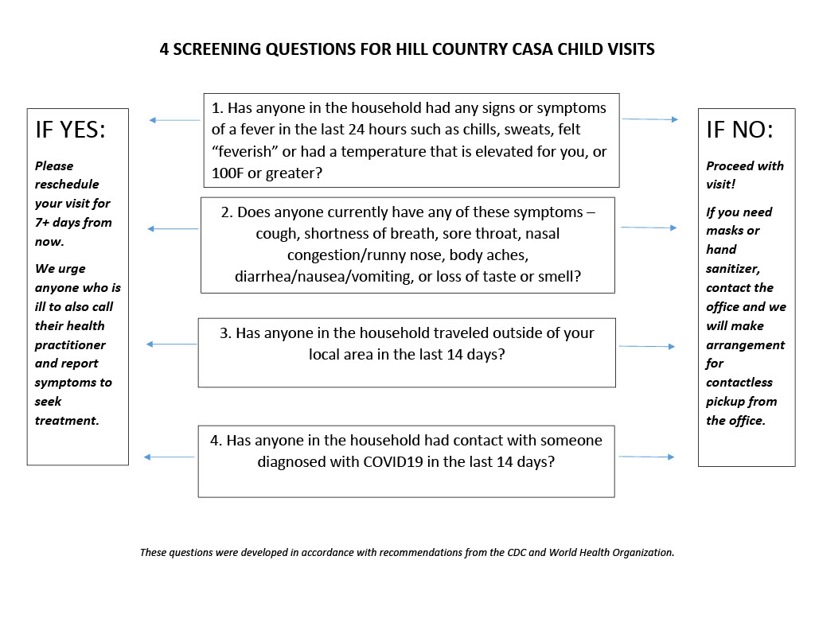

Virtual Visit Tools
Here are three tools for virtual (video) visits with children, placements and others involved in our cases. Depending on your device and the device you’re connecting to, you may use one or more of these options.

App Name | Who can Use? | YouTube Instructions
FaceTime | Apple Device to Apple Device | https://www.youtube.com/watch?v=NyfaJR7BilQ
Google Duo | Android Device to Any Device | https://www.youtube.com/watch?v=c-EMHbvsV7Y
Zoom.us | Any Device to Any Device | https://www.youtube.com/watch?v=HbYHaNvCw9M

