HCCASA CALENDAR + ANNOUNCE LIST December 2020

--------------------------------------------------------------------------------------------------------------------------------------------------------------------------------------------------------------------------------------------------------------------------------------
Press CRTL+Click of the links below to go straight to the topic:

COVID-19 News and Updates
Information for Court Hearings
December + January (so far) Court / Meeting Calendar
Meetings
Child Visits
*NEW* CASA Office Hours + Holiday Schedule
CASA LIVE Virtual Training
CASA At-Your-Own Pace Training
Visitation Protocols
Virtual Visit Tools for CASAs
--------------------------------------------------------------------------------------------------------------------------------------------------------------------------------------------------------------------------------------------------------------------------------------

--------------------------------------------------------------------------------------------------------------------------------------------------------------------------------------------------------------------------------------------------------------------------------------

COVID-19:
We continue to monitor COVID-19 situation in all of our local counties, and statewide.
We are also monitoring the situation within our own child welfare community and gathering information as we receive it from you all, placements, other CASA programs, and CPS.
The number of local cases of COVID-19 is higher than ever before. Exercise caution when going out in public for any reason.
There are many factors affecting the ability to receive timely information about exposure or positive cases in our foster care facilities and homes. Please be vigilant in adhering to health authority guidelines and HCCASA Visitation Protocols to keep yourself safe.
--------------------------------------------------------------------------------------------------------------------------------------------------------------------------------------------------------------------------------------------------------------------------------------

--------------------------------------------------------------------------------------------------------------------------------------------------------------------------------------------------------------------------------------------------------------------------------------

COURT HEARINGS:
All hearings will happen virtually until further notice and definitely through the 2020 holidays.
HCCASA Court Swear In: “Name, Hill Country CASA, Guardian Ad Litem for the Child(ren)”.
Each week, your supervisor will contact you as soon as we have call in information for your hearing.
Any CASA that would like to attend Court by Zoom Video should first watch the Zoom video court training on our vimeo account.
You are welcomed to continue to attend court by phone only, if that is your preference.

-------------------------------------------------------------------------------------------------------------------------------------------------------------------------------------------------------------------------------------------------------------------------------------

-------------------------------------------------------------------------------------------------------------------------------------------------------------------------------------------------------------------------------------------------------------------------------------

CASA CALENDAR DECEMBER 2020 – MID-JANUARY 2021
Abbreviations: Adversarial Hearing (Removal), Family Group Conference (FGC), Transition Plan Meeting (TPM), 60 Day/Status Review (Status), Initial Permanency Hearing (IPH), Permanency Review before Final Order (PH), Permanency Review after Final Order (PR), Progress Review (Progress), Permanency Planning Meeting (PPM), Pre-Trial Conference (PTC), Merits Trial (Merits), Adoption (Adopt) and Dismissal (Final).
All Hearings / Meetings will be held by Zoom / Phone Call. We will send an updated calendar each week to those who need it with call-in information and protocols.
Tuesday, December 1, Gillespie Family Meeting
3:00 Ahrendt Taylor (067) AH

Wednesday, December 2, Kerr Court
9:30 Naumann (Merits) Hug (537) RL
10:00 Moran-Dulaney (PH) Trono (919) CR
11:00 Wheeler (Status) Enochs (567) AH

Friday, December 4, Family Meeting
10:00 Brown Schoenfeld (636) AH

Tuesday, December 8, Family Meeting
3:30 Roach-Morris Blackburn (519) CR

Wednesday, December 9, Kerr Court
9:00 Ortega, N. (PH) Johnson (507) SC
10:00 Erath (PR) Brown (364) RL
11:00 Myhre-Beggs (Status) Berlin (823) RL
1:00 Lacey (Progress) Buck (389) RL
1:30 Runyan (Merits) Gramatikakis (136) RL
2:00 Ballard (Status) Unassigned CR

Thursday, December 10, Family Meetings
9:00-10:00 Holsey Hug (537) GR
10:00-11:00 Bowen Keyes (578) GR
11:00-12:00 Beadman Peterson (551) GR
1:30-2:30 Lochte Darling (862) RL
2:30-3:30 Villalobos Oates (568) RL

Friday, December 11, Bandera Court
9:00 Jennings (Merits) Mirsky (489) GR
9:30 Yeager (PH) Putnam (243) GR
10:00 Sheeds (PR) Ertel/Weaver (326/922) GR
10:30 Bowen (PR) Keyes (578) GR
11:00 Perales (Merits) Helm (304) GR
11:30 Holsey (IPH) Hug (537) GR
1:00 Servellon (Status) Brooks (242) GR

Wednesday, December 16, Kerr Court
9:00 Crider (Progress) Whitecotton (310) RL

Thursday, December 17, Gillespie Court
9:00 Carlos (Status) Kirchner (529) AH
9:30 Nieto (Status) Unassigned AH
9:30 Jones-Rodgers (Merits) Lukacs (439) AH
10:30 Ahrendt (Status) Taylor (067) AH
11:00 Tubbs-Servantez (Status) Unassigned AH

The CASA Office will be closed for the Christmas Holidays starting on Wednesday, December 18 @ 12 PM and we will return to work on Monday, December 28 @ 9 AM.

Wednesday, December 30, Kendall Court
9:00 Grandazzo (Merits) Taylor (067) RL
9:30 Lochte (PR) Darling (862) RL
10:00 Villalobos (PR) Oates (568) RL

The CASA Office will be closed for the New Year’s Holiday on Wednesday, December 30 @ 12 PM and we will return to work on Monday, January 4, 2021 @ 9 AM.

Wednesday, January 6, Kerr Court
9:00 Stewart-Stokes (IPH) Luttrell (676) AH
9:30 Schneider (Merits) Griffith (428) CR
10:00 Salinas (IPH) Clyburn (597) RL
10:30 Ybarra (IPH) Martin (660) AH
11:00 Guzman (PR) Taylor (067) RL
11:30 Burrow (Status) Unassigned AH

Tuesday, January 12, Mediation
10:30 Mayes Prince (105) RL

-------------------------------------------------------------------------------------------------------------------------------------------------------------------------------------------------------------------------------------------------------------------------------------

--------------------------------------------------------------------------------------------------------------------------------------------------------------------------------------------------------------------------------------------------------------------------------------

MEETINGS:
As meetings are scheduled on your case, your Supervisor will contact you directly with call-in information.
We expect meetings and mediations to continue to be held virtually for the foreseeable future.
Your supervisor will give you the option to attend meetings and mediations either virtually (with video) or by phone only.
If you choose to attend meetings virtually, please be mindful of your background and follow the normal protocols for meetings in person regarding dress, decorum.
--------------------------------------------------------------------------------------------------------------------------------------------------------------------------------------------------------------------------------------------------------------------------------------

--------------------------------------------------------------------------------------------------------------------------------------------------------------------------------------------------------------------------------------------------------------------------------------

CHILD VISITS:
Texas CASA’s Board of Directors has waived the requirement for face to face contact with your assigned children through January 2021.
However, based on feedback from you and in the best interest of our children, we are considering volunteer requests for a face to face visit on a case by case basis.
Please let your Case Supervisor know if you feel you need to have a face to face visit with your child(ren). The Case Supervisor and Program Director will discuss the situation and offer a waiver to allow the visit whenever safely possible.
Once you have a waiver in place, you do not need to seek additional waiver to have additional face to face visits. We just ask that you follow court orders, our visitation protocols, and only visit if you are comfortable to do so.

Per court order, all adult participants in face to face visits must wear a mask for the duration of the visit. We will provide you with a copy of the HCCASA visitation protocols if you will be making a face to face visit.
HCCASA has masks, disposable gloves and hand sanitizer for you – let us know if you would like to drop by for contactless pickup and we will make an appointment at a time convenient for you.

------------------------------------------------------------------------------------------------------------------------------------------------------------------------------------------------------------------------------------------------------------------------------------

--------------------------------------------------------------------------------------------------------------------------------------------------------------------------------------------------------------------------------------------------------------------------------------

CASA OFFICE:
When the office is open, we welcome visitors by appointment (and subject to screening and temperature check upon arrival). All visitors and staff will be required to wear a mask the entire duration of their visit to the CASA office.

If you need a face to face appointment on a day the office is not open, contact your Supervisor and we’ll be pleased to meet your need.

You’ll notice when you visit the front door is locked; this is to minimize walk-in traffic. Please ring the doorbell for service.

HCCASA office will be reverting to a partial open schedule, due to rising COVID-19 cases, through the month of December 2020.

Though our in-office hours are reduced through the end of 2020, we will still be working normal hours (mostly remotely) and will continue to be here for support to all our volunteers doing important work with children.
The week of Thanksgiving (November 23, 2020), the HCCASA office will be closed all week. Staff will work remotely Monday, Tuesday, and Wednesday until 12 PM, and observe the holiday the rest of the week.
For the weeks of November 30, December 7, and December 14, 2020 HCCASA office will be open Monday, Tuesday and Thursday from 9 AM - 1 PM. Each day, two staff members will be in the building. Wednesdays and Fridays all staff will work remotely.
Monday – Stephanie and Amy
Tuesday – Goldie and Raquel
Thursday – Colleen and Judy

The CASA office shall close at noon on December 18, 2020 and reopen on January 4, 2021 for the Christmas Holidays.

Staff shall work remotely on December 28 – noon on December 30.

After December, we will assess the need for, and safety considerations of returning to the office, based on authority guidelines and local case and hospitalization rates. We will send this information out with our January 2021 Calendar + Announcements.

--------------------------------------------------------------------------------------------------------------------------------------------------------------------------------------------------------------------------------------------------------------------------------------

--------------------------------------------------------------------------------------------------------------------------------------------------------------------------------------------------------------------------------------------------------------------------------------

CASA VIRTUAL TRAINING:
Weekly Zooms will resume in mid-January 2021.
Please see the next section for At-Your-Own-Pace learning options!

--------------------------------------------------------------------------------------------------------------------------------------------------------------------------------------------------------------------------------------------------------------------------------------

--------------------------------------------------------------------------------------------------------------------------------------------------------------------------------------------------------------------------------------------------------------------------------------

AT YOUR OWN PACE LEARNING:
Resources/Independent Study Pages on hccasa.org: We have posted tons of local resources and online trainings on our webpages devoted to these two subjects – much of which is based on your feedback in our Spring 2020 HCCASA Program Evaluation.
Click the links below to go straight to these pages.
HCCASA Resources & Independent Study (and Vimeo Account Info)

Texas CASA Distinguished Speaker Series: This year, Texas CASA will not be hosting an in-person Texas CASA Conference. They are going to have a series of Zooms instead, with four planned discussions with national experts on various relevant topics, on Thursdays at 11 AM from October 29 – November 18.
We encourage you to Register and tune in to any or all of these talks as you’re available. Don’t forget to log these hours in Optima for continuing education credit!

--------------------------------------------------------------------------------------------------------------------------------------------------------------------------------------------------------------------------------------------------------------------------------------

CHILD VISIT PROTOCOLS - The following conditions will apply to visits for the foreseeable future:
- Both you as the CASA advocate and the current placement need to agree to the visit. If the placement has an objection, find alternative means to make the visit. Those alternatives could be:
- Drive by visit where the placement and child go out to the porch and/or sidewalk to visit with you in your car
- Visit outside with social distancing and masks
- Meet placement/children at a public location and visit over a meal
- If no other options, do a virtual visit – let your supervisor know if placement will not allow you to visit
- Before your visit, check with the placement about any contact with someone who has been sick, quarantined or tested positive for COVID-19 (see screening questions on the next page). You should also be ready to answer these questions about yourself.
- During visits you are encouraged to wear a mask and practice social distancing to the best of your ability. If a placement requires that you wear a mask, please do so (CASA office can provide a mask for you and the child(ren) you visit). In addition, different counties and municipalities have different emergency rules, so please be aware whenever you travel to those areas. These precautions are to protect you from bringing illness home or from bringing illness to a child’s home.
- Until further notice, transportation of children is suspended. If you need an exception, contact the Program Director.
- Due to the ability of this virus to live on surfaces, please do not bring your children gifts, clothing or toys. If your child has an immediate need, please contact your Case Supervisor and arrangements will be made to have a gift card provided to the placement to meet that need.
  - You may take a meal or snack to the visit with you to share with your child; please don’t take any food not intended to be consumed during the visit.
- Courts, Mediations and CPS meetings are still operating via teleconference/Zoom until August 1, 2020. We will continue to provide you a schedule with access information in advance, as we have over the last months.
- Please make sure to documents all of your contacts and visits (whether virtually, by phone or in person) in Optima and in a timely manner. Our grants are dependent on the documentation you keep.
- Should you become ill and suspect you have exposed a child after a visit, please make sure to notify the individuals with whom you have been in contact so they can take the appropriate steps. Also, notify your Case Supervisor.
- If you identify issues of abuse or neglect during a visit, please report the information you obtained to:
- CASA Case Supervisor
- CPS Caseworker through email and phone call
- CPS Child Abuse Hotline 1-800-252-5400
- Contact local law enforcement and request a welfare check

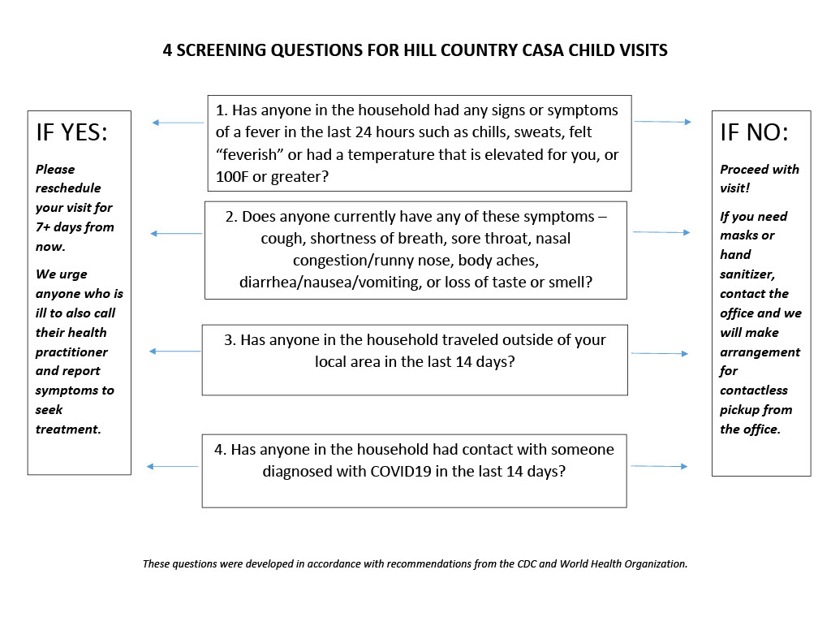

Virtual Visit Tools
Here are three tools for virtual (video) visits with children, placements and others involved in our cases. Depending on your device and the device you’re connecting to, you may use one or more of these options.

App Name | Who can Use? | YouTube Instructions
FaceTime | Apple Device to Apple Device | https://www.youtube.com/watch?v=NyfaJR7BilQ
Google Duo | Android Device to Any Device | https://www.youtube.com/watch?v=c-EMHbvsV7Y
Zoom.us | Any Device to Any Device | https://www.youtube.com/watch?v=HbYHaNvCw9M

